Practical 6 Aggregate functions
(Reference: SQL*Plus User’s Guide and Reference Chapter 6 Formatting SQL*Plus Reports)
Learning Objective:
- Formatting output

(Refer to the OrderProcessingScenario.doc ERD to understand how to join the tables correctly.)
(You will write similar queries as presented here for your TASK 7 in your practical assignment.)

Execute the newData.txt script to create more records in your database.

Setting the SQL*Plus configuration for reporting

When you run a SQL query, the output is a form of report. For example, let’s say you would like to list customers and their order details. You might write:
select C.cust_no, C.cust_name,
F.order_no, F.order_date,
M.description, L.quantity, L.price,
(L.quantity*L.price) as Sub_Total
from customer C, food_order F, order_list L, menu M
where C.cust_no = F.cust_no AND
F.order_no = L.order_no AND
L.menu_id = M.menu_id
order by 1, 3;

The output of the query may look like this:
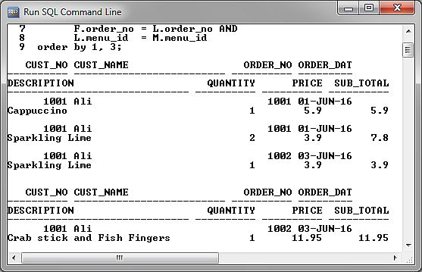

…looks messy and difficult to read.
You need to format the output to make it into a presentable report.

Set the width and length of the report.
set linesize 120 –- default linesize is 80
set pagesize 30 – default pagesize is 14
(execute a SHOW ALL command to see all the default settings of SQL*Plus)

After setting the report width and height, execute the SQL statement again and observe the result.
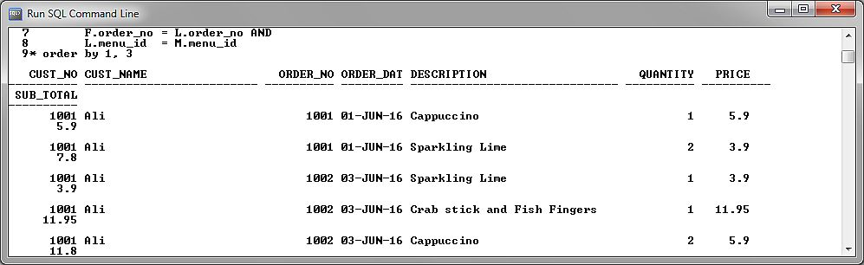

Much better, but the total character count of each line still exceeds your linesize of 120.
(Linesize 120 is the limit of the number of characters that can be printed across an A4 page in landscape orientation for font size 12)

Truncate the output of some data item to reduce the length of each row to within 120 characters.
column cust_name format A15
column description format A25 truncate

Now, execute the SQL statement again, the report should look presentable
**
CUST_NAME in customer table is defined as a string of 25 characters
DESCRIPTION in menu table is defined as a string of 30 characters

Look at the report and decide if any other attributes need to be format further.

Adding a title to the report
(Refer Chapter 6, Chapter 12 of the SQL*Plus User’s Guide and Reference)
Adding a title for a report:
TTITLE CENTER 'Customer Analysis for ' _DATE -
RIGHT 'Page:' FORMAT 999 SQL.PNO SKIP
Execute the SQL query again.

You should get an output like this:
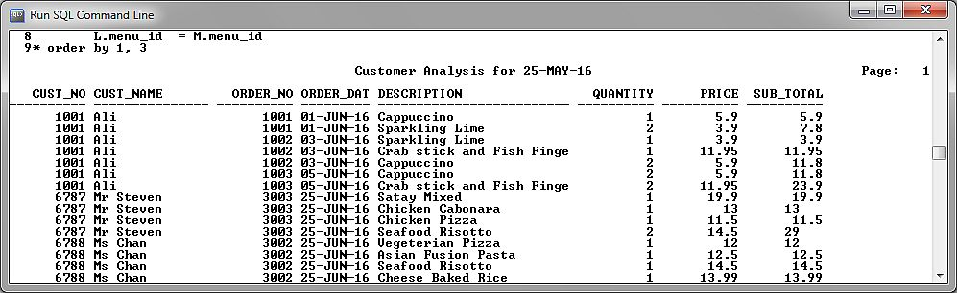

Now, read Chapter 6 and use the BREAK, COMPUTE command to enhance your reports further.

e.g. using BREAK
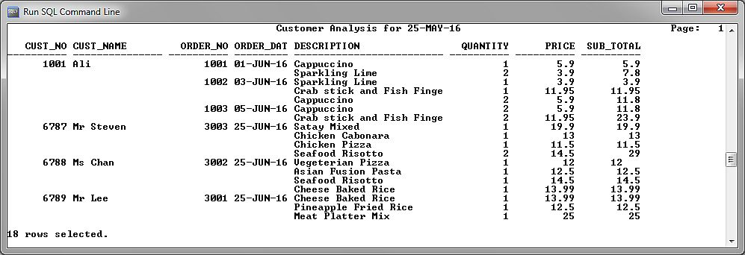

e.g. using BREAK and COMPUTE and other formatting
